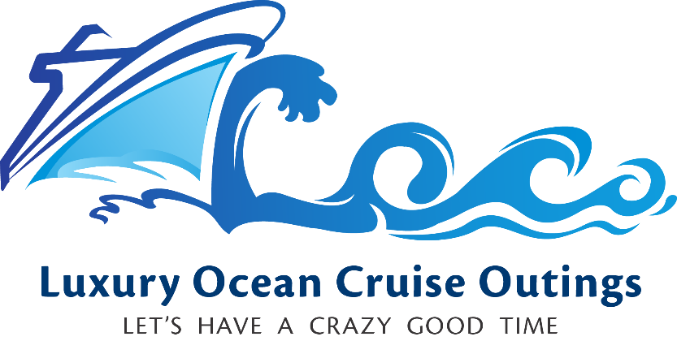

# **System Specification Document**

## Overview

Our mission at Luxury Ocean Cruise Outings is to provide the accurate and efficient ability to coordinate cruise bookings for our growing list of affiliate luxury cruise ship owners and cruise lines. We desire a simple menu-based system to perform core functions that are essential to our daily operations.

The envisioned system will include three primary components: ships, cruises, and passengers. The Luxury Ocean Cruise Outings company does not own ships; instead, it creates cruises using available ships. Once a ship is placed “in service,” it is available for cruises. Passengers can be added to cruises. Here are the relationships of these components:

* Ships have unique names.
* Cruises have unique names and are assigned to ships.
* Ships can have multiple cruises.
* Each ship has a finite number of passenger cabins (Balcony, Ocean View, Suite, and Interior). Overbooking is not permitted.
* Passengers are assigned to cruises.

## System Menu

We require a simple text-based menu system that should resemble the illustration below. [A text version](https://learn.snhu.edu/d2l/lor/viewer/view.d2l?ou=6606&loIdentId=24108) of this table is also available.

